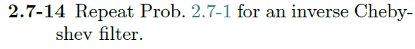

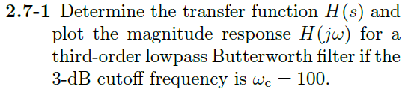

We know:

$$ω_{c}=100 \frac{rad}{sec}$$

$$α_{s}=20 dB$$

Using eq 2.53 in book:

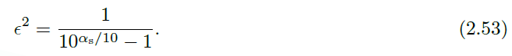

$$ϵ =0.1005$$

Then, using eq 2.42 and eq 2.51 in book:



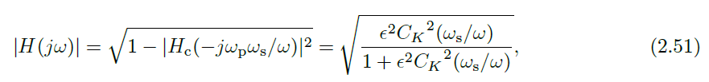

We know that $\left|H\left(jω_{c}\right)\right|=\frac{1}{\sqrt{2}} so$

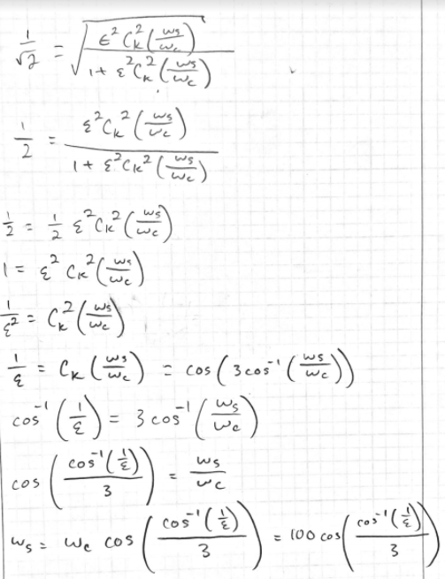

Then our stopband frequency is

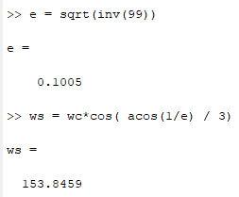

Now, using eq 2.47, 2.55, and 2.56 we can figure out the poles/zeros. Eq 2.55 can be set equal to 2.47 to remove the passband frequency variable.



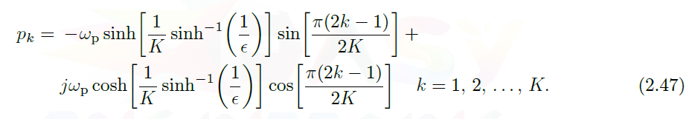



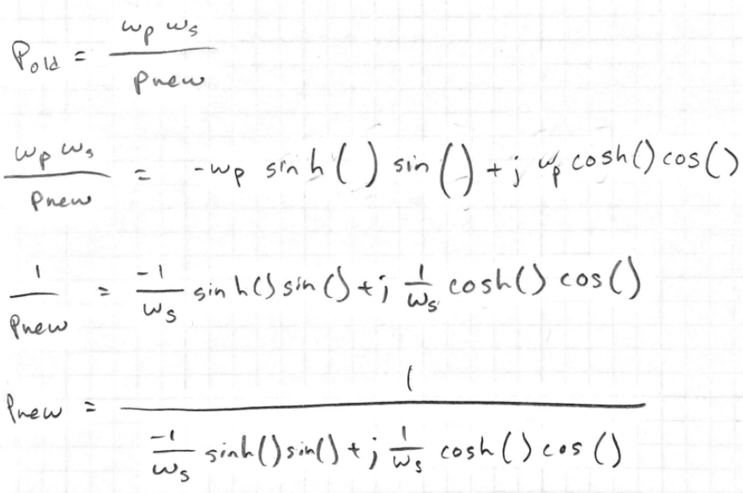

In MATLAB,

